Assessment of Attacks using Wireshark
From the given .pcap file, I have analyzed its traffic and find the following risks
Risks
1. DoS/DDoS
We found DoS (Denial of Service) attack is a type of cyber-attack that aims to disrupt the normal functioning of a targeted system or network by overwhelming it with a flood of traffic or requests, rendering it unable to respond to legitimate requests. A DDoS (Distributed Denial of Service) attack is a more sophisticated version of a DoS attack, in which the attack traffic comes from multiple sources, often using botnets or compromised devices, making it more difficult to mitigate.
By analysing a pcap file, we examine the traffic patterns and characteristics of an attack, such as the type and volume of traffic, the source and destination IP addresses, and the protocols used. We have found this is a DoS/DDoS attack performed on the network. We have analysed them by applying different filters as given below;
1. We checked SYN flood attack using the following filter and we got the results as given below;
tcp.flags.syn == 1 and tcp.flags.ack == 0
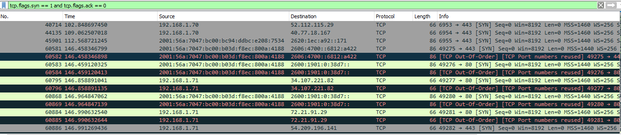
2. We checked UDP flood attack on the DNS is analyzed using the following filter
udp.dstport == <port_number>
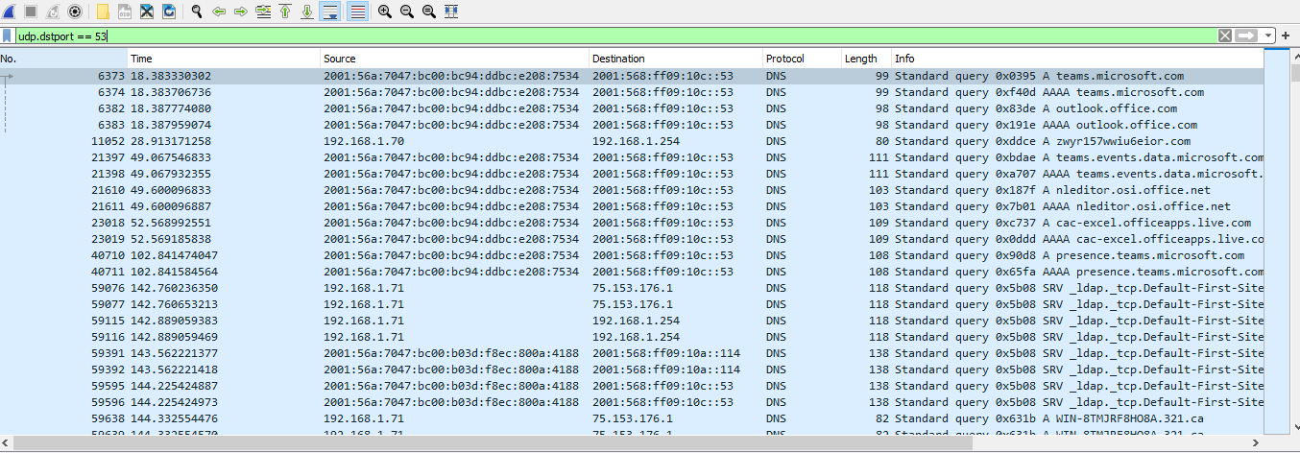

3. We checked HTTP flood attack on the port 80, using the following filter
tcp.dstport == 80 and http.request
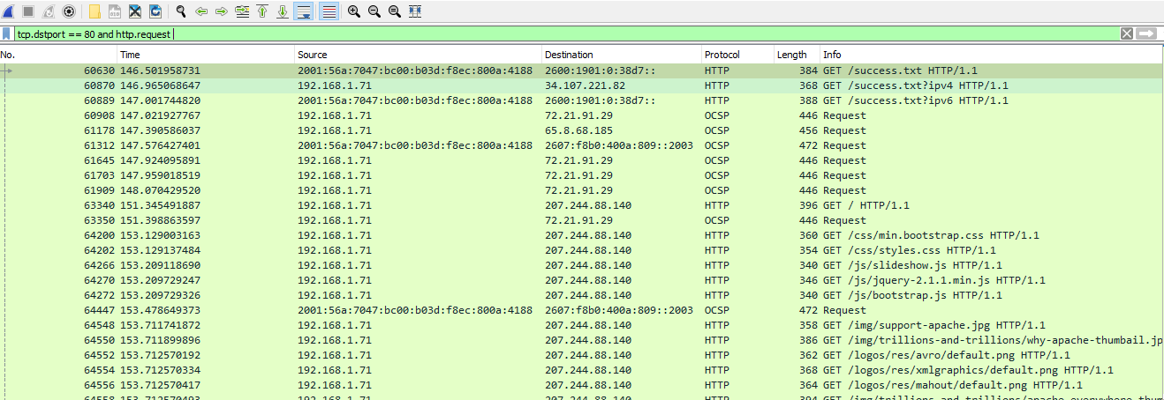4. We checked Slowloris attack on the network using the following filter
tcp.flags.push == 1 and tcp.flags.ack == 0 and tcp.flags.syn == 0
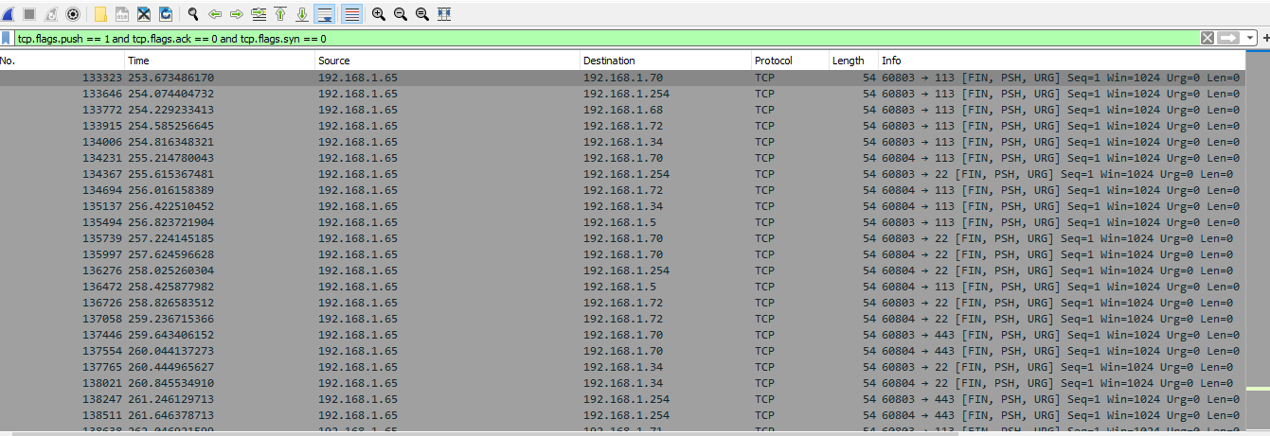
Prevention
- Use traffic filtering and rate limiting to prevent excessive traffic from reaching the target server or network.
- Implement load balancing and redundant servers to distribute traffic and handle the load in case of a DoS attack.
- Use firewalls and intrusion detection/prevention systems (IDS/IPS) to identify and block malicious traffic.
2. Network Scanning
A network scanning attack is a type of cyber-attack in which an attacker uses automated tools to scan a network for vulnerabilities or open ports in order to identify potential targets for further exploitation. In this .pacp file, we have found this attack because it indicates network scanning attacks include large numbers of ICMP requests or ARP requests, which may be used to identify active hosts on a network, as well as unexpected or unusual traffic patterns that may indicate reconnaissance activity.
We used following filter to analyze the network scanning attack on the network as given below
ip.flags.df==0 && ip.ttl==1
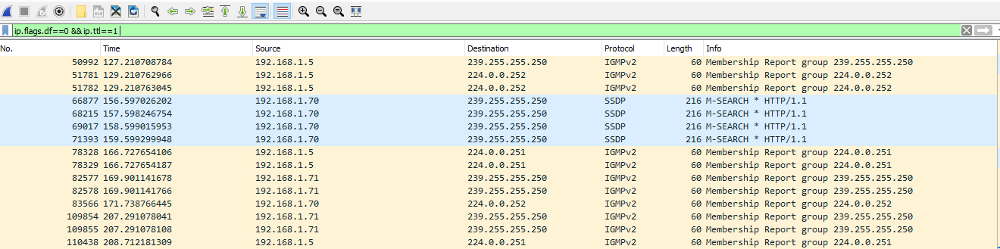
Preventions
- Implement network segmentation and access control measures to restrict access to critical systems and data.
- Use intrusion detection/prevention systems (IDS/IPS) to detect and block suspicious activity.
- Use port scanning detection tools to detect and alert on port scanning activity.
3. Man-In-The-Middle Attack
A Man-in-the-middle (MITM) attack is a type of cyber-attack where an attacker intercepts communication between two parties to steal information or to modify it in transit without the knowledge of either party. The attacker typically positions themselves between the two communicating parties and relays messages between them while eavesdropping on the traffic.
Some signs of a Man-in-the-middle attack in a pcap file include:
- Presence of duplicate packets, packets with incorrect checksums, packets with incorrect sequence numbers
- Unexpected changes in the source or destination IP addresses or port numbers
For ARP Replies:
Using filter arp && arp.opcode == 2 that will show the ARP replies
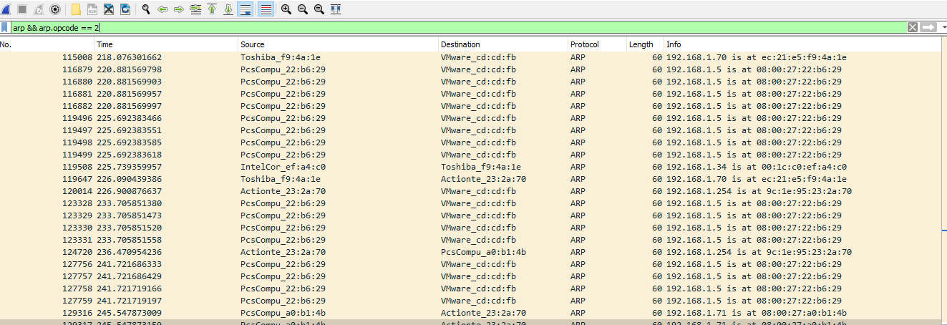
For DNS Queries:
Using filter dns.flags.response == 0 && dns.count.queries == 1
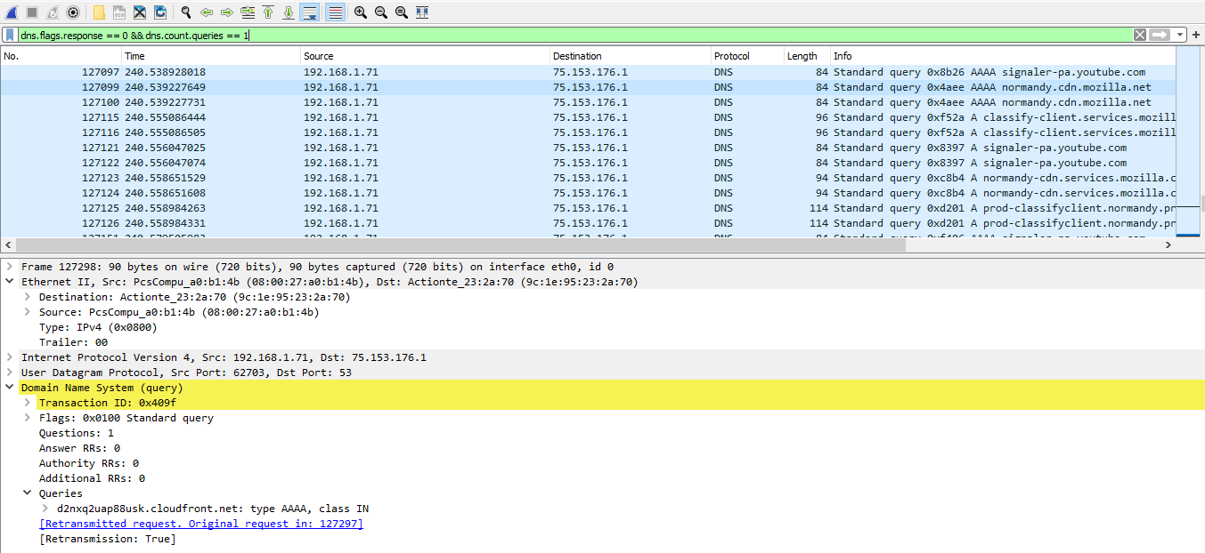
For SSL/TLS Connections:
Using filter ssl.handshake.extensions_server_name
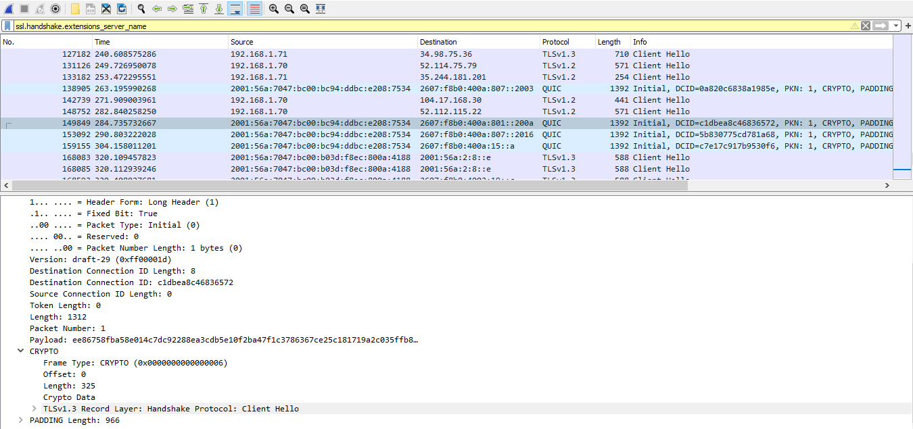
Preventions
- Use secure communication protocols, such as HTTPS, SSL/TLS, and SSH, to prevent eavesdropping and tampering.
- Implement endpoint authentication and encryption to prevent unauthorized access.
- Use anti-virus and anti-malware software to detect and remove malicious software that could be used in a MitM attack.
4. Passwords Cracking
Password cracking attacks are a type of cyber-attack where an attacker attempts to gain unauthorized access to a system or account by guessing or cracking the password. The attacker may use various techniques such as brute-force attacks, dictionary attacks, or social engineering to crack the password and gain access to the system or account.
Using filter http.request.method == POST, we got following results
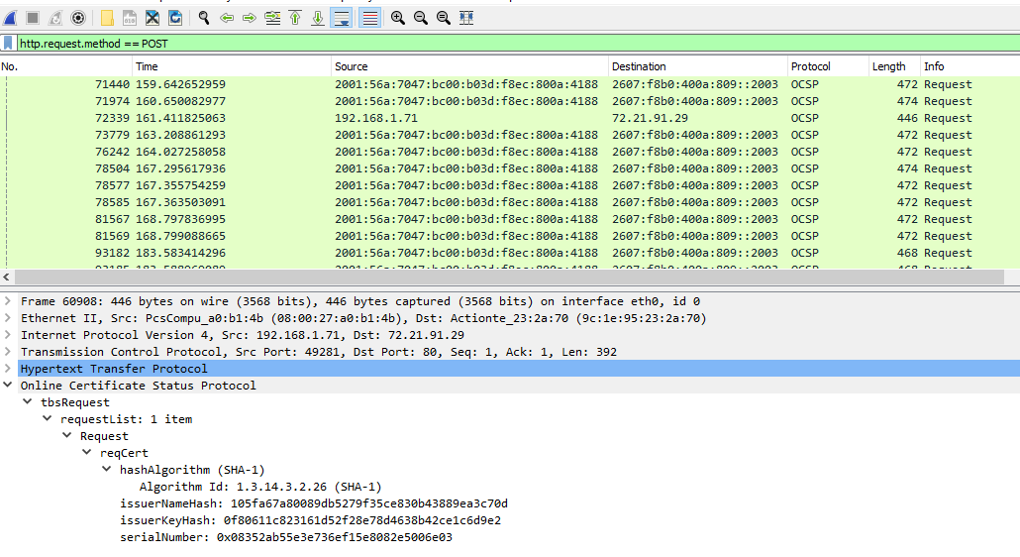
Using filter tcp.port eq 80, following are the results
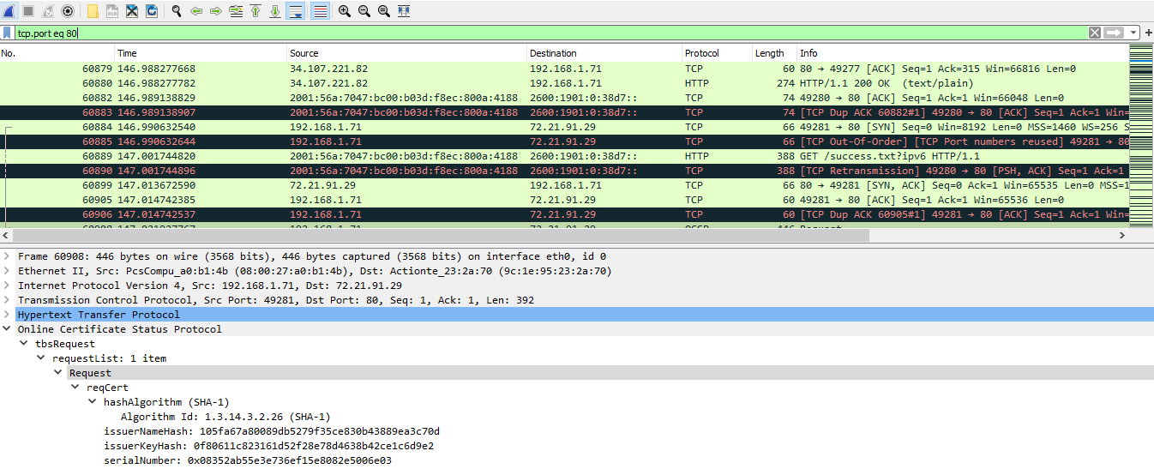

Preventions
- Use strong passwords and implement password policies that require regular password changes.
- Implement multi-factor authentication to add an extra layer of security to user accounts.
- Monitor and log failed login attempts to detect and alert on password cracking attempts.
Table of Assets
Machine Name | OS | MAC | IP
Actionte_23:2a:70 | Linux | 9c:1e:95:23:2a:70 | 192.168.1.254
VMware_cd:cd:fb | Windows | 00:0c:29:cd:cd:fb | 192.168.1.65
Toshiba_f9:4a:1e | Windows | ec:21:e5:f9:4a:1e | 192.168.1.70
PcsCompu_a0:b1:4b | Windows | 08:00:27:a0:b1:4b | 192.168.1.71
D-Link_50:a5:08 | IOS | 00:0f:3d:50:a5:08 | 192.168.0.1
IntelCor_ef:a4:c0 | Windows | 00:1c:c0:ef:a4:c0 | 192.168.1.34

